Algebra 3-4 Name: ____________________

Chapter 6 Preview Block: ________

In questions 1 – 4, evaluate the expression.

1. 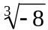 2. 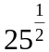

3. 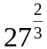 4. 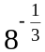

In questions 5 – 8, simplify the expression.

5. 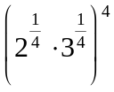 6. 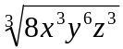

7. 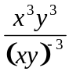 8. 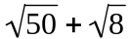

In questions 9 – 12, solve the equation. Check for extraneous solutions.

9. 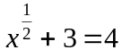 10. 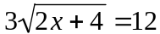

11. 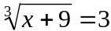 12. 